Abstract:
EduGenie is an AI-powered learning assistant developed using Python, FastAPI, HTML, CSS, Jinja2, and Google Gemini API. It helps students by providing intelligent educational assistance through multiple learning modules. The application can answer academic questions, summarize lengthy notes, explain difficult concepts, generate quizzes, and recommend personalized learning paths. EduGenie aims to simplify learning and improve students' understanding through AI-generated educational content.

Objectives:
- Develop an AI-powered educational assistant.
- Simplify difficult concepts using AI.
- Provide quick summaries of lengthy notes.
- Generate quizzes for self-assessment.
- Create personalized learning paths.
- Improve students' learning experience.

Technologies Used
Technology | Purpose
Python | Backend Development
FastAPI | REST API Framework
HTML | Frontend
CSS | UI Design
Jinja2 | Template Rendering
Google Gemini API | AI Response Generation
VS Code | Development Environment

System Architecture:
User
│
▼
HTML + CSS Frontend
│
▼
FastAPI Backend
│
▼
Google Gemini API
│
▼
Generated Response

Modules:
1.Question Answering Module
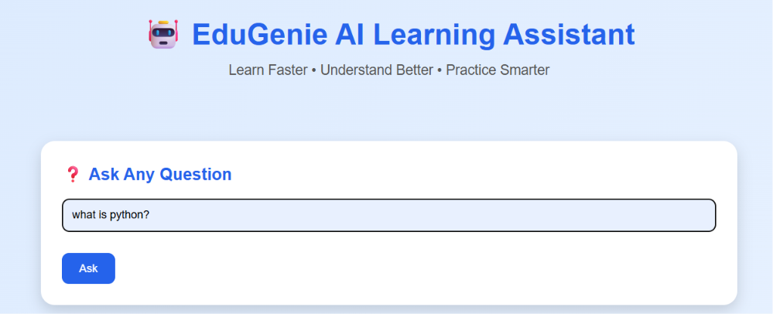
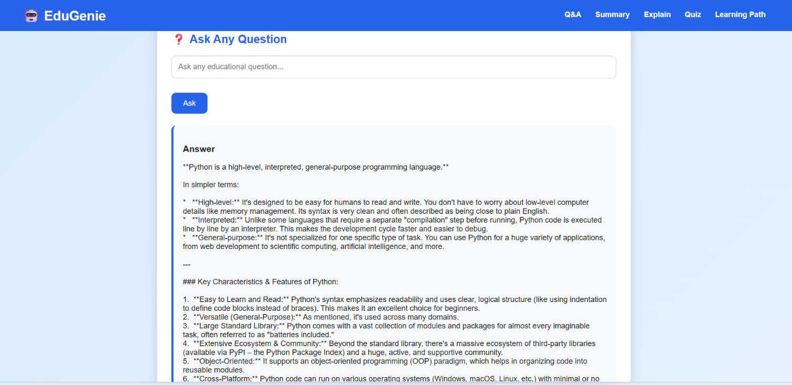
Purpose:
Allows students to ask educational questions and receive AI-generated answers instantly.
Input:
Question
Output:
Detailed educational answer

2. Summarization Module
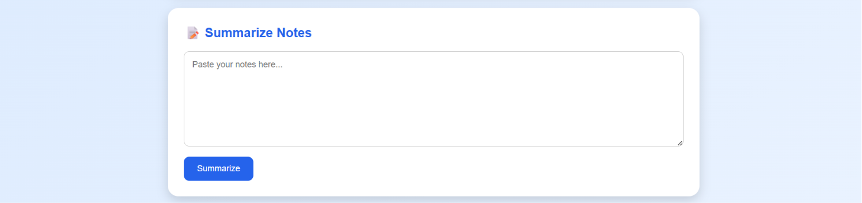
Purpose:
Converts long notes into short summaries while preserving important information.
Input:
Long Notes
Output:
Summary

3. Concept Explanation Module
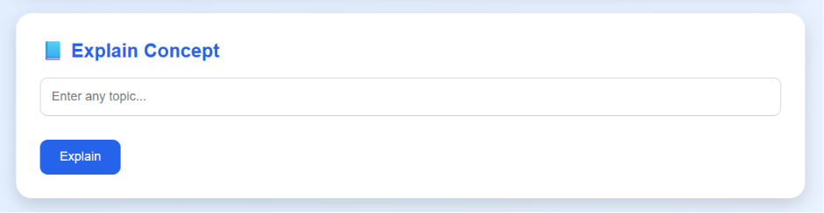
Purpose:
Explains difficult concepts in simple language suitable for beginners.
Input:
Topic
Output:
Easy-to-understand explanation

4. Quiz Generator
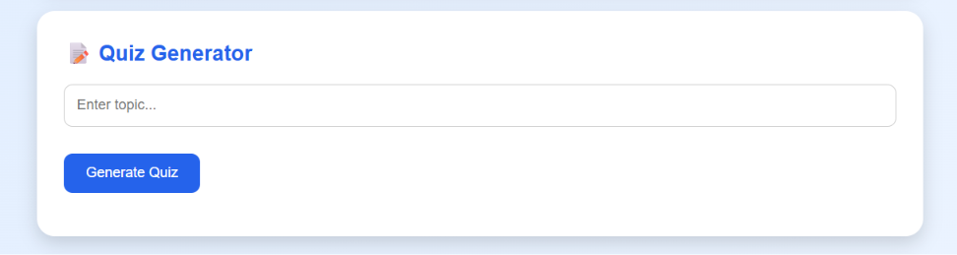
Purpose:
Automatically creates multiple-choice questions for revision and practice.
Input:
Topic
Output:
MCQ Quiz with correct answers

5. Personalized Learning Path
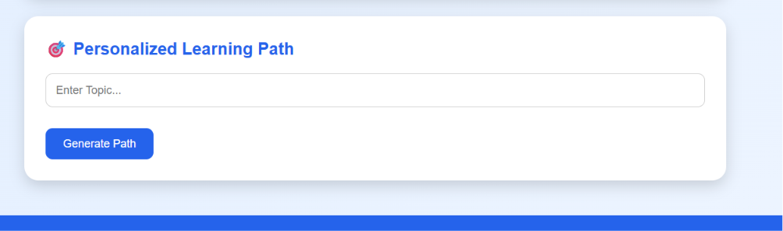
Purpose:
Provides a structured roadmap from beginner to advanced concepts.
Input:
Topic
Output:
Step-by-step learning roadmap

Working Procedure:
- User opens EduGenie.
- Selects a learning module.
- Enters the required input.
- FastAPI receives the request.
- Backend sends prompt to Google Gemini API.
- Gemini generates educational content.
- Response is displayed on the webpage.

Features:
- AI-powered educational assistant
- Question answering
- Text summarization
- Concept explanation
- Quiz generation
- Personalized learning path
- Simple responsive interface
- Fast response time

Advantages:
- Saves study time
- Easy to use
- Improves understanding
- Personalized learning
- AI-generated educational content
- Supports self-learning

Applications:
- Schools
- Colleges
- Online Learning Platforms
- Competitive Exam Preparation
- Self-learning

Future Enhancements:
- Student Login System
- User Progress Tracking
- Voice Assistant
- PDF Upload
- Image-based Question Answering
- Dark Mode
- Multiple Language Support
- Performance Dashboard

Conclusion:
EduGenie successfully demonstrates the integration of Artificial Intelligence into education. Using Google Gemini and FastAPI, the application provides an intelligent learning environment where students can ask questions, summarize notes, understand concepts, practice quizzes, and receive personalized learning recommendations. The project showcases modern AI technologies that enhance learning efficiency and educational accessibility.

